**COSC 2325 Computer Organization**

**Assignment 9**

**Due: 23:59:00, 11/07/2022 (Monday)**

**Andrew Kalathra, L20498001**

**If you use Qtspim:**

In the Settings menu of SPIM set Bare Machine OFF, Allow Pseudo Instructions ON, Load Trap File ON, Delayed Branches OFF, Delayed Loads OFF, Mapped IO ON, Quiet OFF. The starting address of Data Section is 0x10000000.

**If you use Mars:**

Menu → Settings → Permit extended (Pseudo) instructions and formats The starting address of Data Section may be 0x10010000

(Please check Settings->Memory Configuration… -> .data base address)

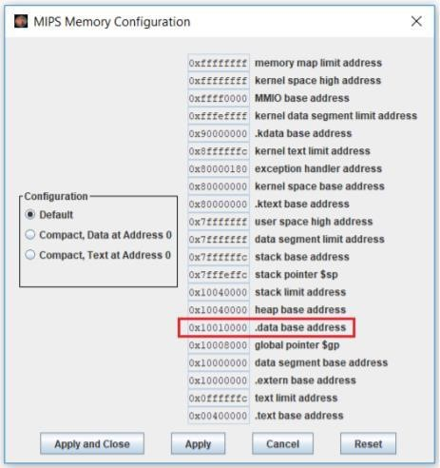

1. Please complete the provided A9_Q1.asm to solve the problem below: Declare three arrays, each of the same size:

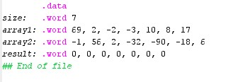

Initialize a base register for each array (use ***la*** instruction.) Now implement a loop that multiplies corresponding elements in the first two arrays and stores the result in the corresponding element of the result array. Do this by moving each of the three base registers to its next array element after each multiplication.

1. Please translate the pseudo-instructions below to basic assembly instructions
   1. li $v0, 0x11072022

lui $1, 0x1107

ori $2, $1, 0x2022

* 1. li $v0, -1107

addiu $2, $0, -1107

* 1. li $v0, 2022

ori $2, $0, 0x7E6

1. Computer the area of a triangle (area=height*base/2): Please complete A9_Q3.asm that repeatedly prompts the user for the height and base of the triangle, and then prints out the area of the triangle. Use integer math. Exit when the user enters 0 for the height.

Example (Mars)

